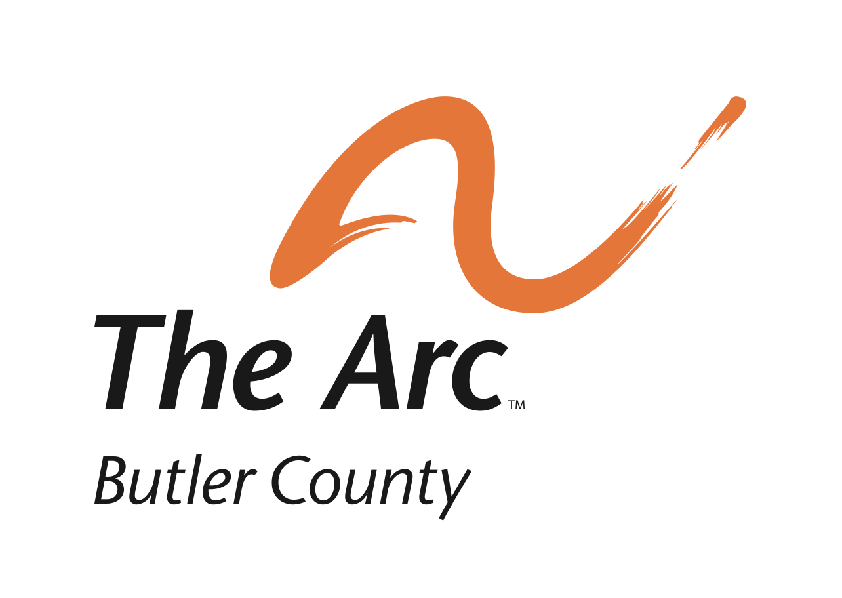
Membership Application

Name: _______________________________________________________________

Street Address: _______________________________________________________

Town: __________________________________ State: ________ Zip: ________

Phone Number: ___________________Cell/Mobile Phone Number: _________

E-mail Address: ______________________________________________________

Please check (as many as apply) the reasons why you are joining The Arc:

___ Interest in ADVOCACY for people with disabilities and/or their families.

___ Public/government affairs that affect people with disabilities.

___ Get to know other families with members who have developmental disabilities.

___ Provide volunteer help for events connected with The Arc.

___ Support for the goals of The Arc.

___ Stay current on information about supports for people with developmental disabilities.

___ Benefits of membership in The Arc (e.g., discounts on purchases, insurance, etc.)

___Other: ____________________________________________________________

Please send your membership application to:

Mary May, Membership Chair
The Arc of Butler County
282 N. Fair Avenue
Hamilton, OH 45011

Annual Dues for The Arc: $20.00

